

Market Regime Classification and Dynamic Portfolio Allocation

Introduction and Project Statement:

Volatility reflects the degree of fluctuation in asset prices and is closely linked to market risk. However, classifying markets into discrete volatility states remains challenging, as similar patterns can arise across fundamentally different economic environments. This ambiguity limits the effectiveness of traditional modeling approaches.

Common measures of market volatility, such as the VIX (Volatility Index) and VIX futures, provide useful information about current and expected market conditions but are not inherently predictive. The VIX captures implied volatility, while VIX futures reflect market expectations; however, neither directly forecasts future realized volatility.

Modeling market behavior therefore requires identifying patterns in historical data and mapping them to future conditions. This task is complicated by the non-stationary nature of financial markets and the diversity of market participants, which limit the applicability of traditional parametric methods. To address these challenges, we implement a machine learning framework that combines unsupervised clustering to identify latent market regimes with supervised classification to predict future regime transitions. This framework enables a forward-looking approach to regime detection, supporting more adaptive portfolio allocation decisions.

Context

Volatility is a primary driver of market regimes, influencing investor behavior and asset performance (Trading Dude, 2025). As these regimes are not directly observable, machine learning techniques—particularly clustering methods such as K-means—provide a data-driven approach to identify latent market states without predefined labels (Aslam, 2025).

Effective portfolio allocation also requires dynamic rebalancing to maintain risk exposure under changing market conditions (BlackRock, 2024). This motivates a framework that links regime identification with allocation decisions.

Our approach combines unsupervised learning to identify market regimes with supervised methods to predict their evolution, enabling a forward-looking framework for regime-based portfolio allocation.

Data Preparation:

To support our analysis, we collected data from two primary public sources: market data from Yahoo Finance (via the “yfinance” Python library) and macroeconomic data from the Federal Reserve Economic Data (FRED) API. Yahoo Finance provided a broad set of financial assets, including equity indices, sector ETFs, treasury bond proxies, commodities, and the VIX, while FRED supplied key macroeconomic indicators, specifically 2-year and 10-year Treasury yields.

Because these data are reported at different frequencies, all series were aligned to a weekly frequency (end-of-day Friday). Price-based series used the last observation of each week, while macroeconomic data were resampled and forward-filled to maintain temporal continuity. The datasets were then merged on a common date index and standardized.

We constructed two datasets for distinct purposes. The first is a cross-asset dataset capturing broad market behavior for portfolio allocation. The second focuses on engineered features, including returns, realized volatility, volatility-of-volatility, momentum, VIX-based measures, and the 10Y–2Y yield spread, which support regime detection and supervised learning.
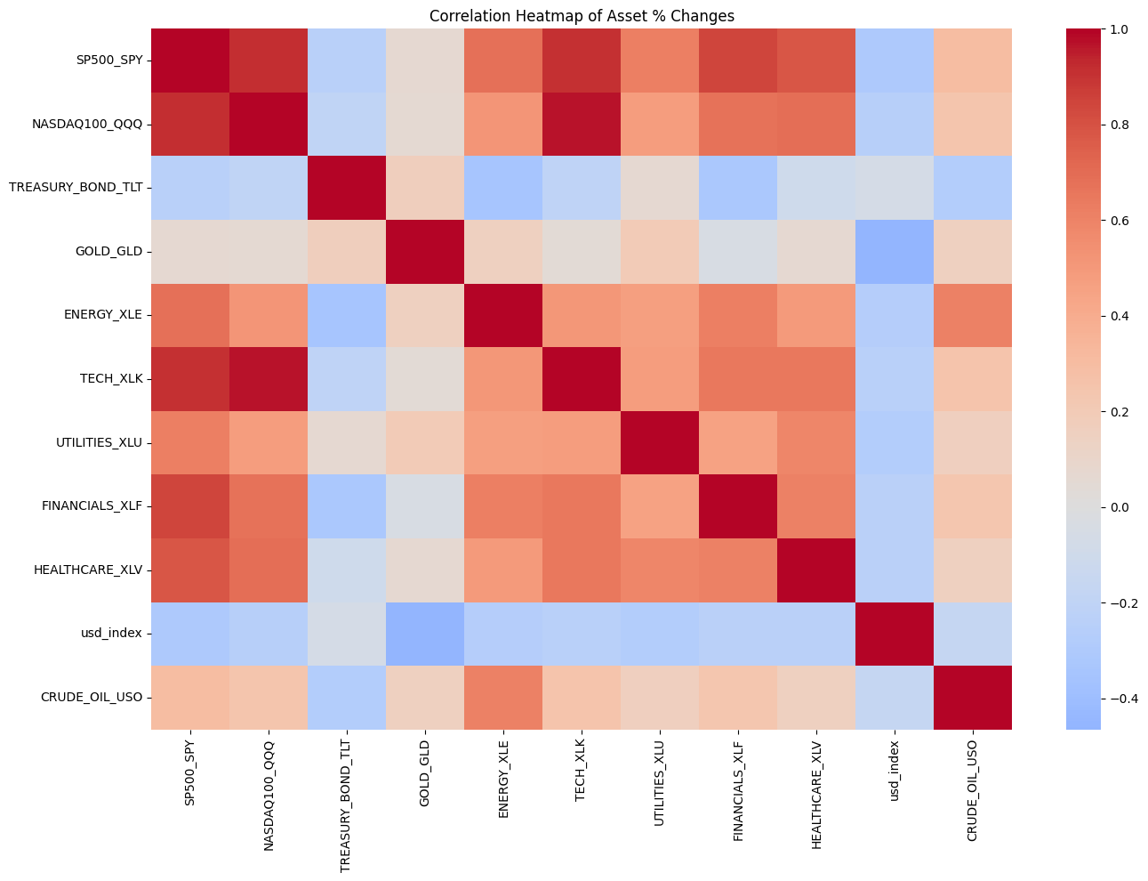
Figure 1. Correlation heatmap of weekly asset returns, illustrating co-movement among equity assets and weaker or negative relationships with defensive assets such as Treasury bonds and the U.S. dollar.

To better understand asset relationships, we examine the correlation structure of weekly returns (Figure 1). Equity assets such as SPY, QQQ, and sector ETFs exhibit strong positive correlations, indicating similar behavior under typical market conditions. In contrast, Treasury bonds (TLT) and the U.S. dollar show weaker or negative correlations, reflecting their role as defensive assets. This diversification provides the basis for regime-based allocation and supports the use of unsupervised methods to identify market regimes.

Unsupervised:

We applied K-means clustering to identify latent market regimes, as these regimes are not directly observable in financial data. Clustering methods such as K-means provide a data-driven approach for identifying underlying structures without predefined labels (Aslam, 2025). The clustering process used seven weekly features, including overall market volatility, volatility slope, volatility-of-volatility, VIX, treasury yield spread, and realized S&P 500 volatility (e.g., 4-week and 12-week measures).

To prevent data leakage, the dataset was split chronologically, and the K-means model was fit only on the training period. Cluster labels for the validation and test sets were assigned using the fitted model. All features were standardized using a scaler fit on the training data, with the same transformation applied to out-of-sample observations.

We evaluated multiple cluster configurations using the elbow method, silhouette score, and cluster stability. While silhouette scores favored fewer clusters, we selected three based on interpretability and their usefulness for downstream tasks.

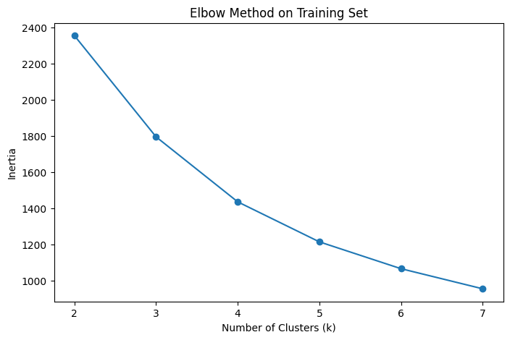Figure 2. Elbow method applied to the training dataset, showing the relationship between the number of clusters and inertia. Improvements diminish beyond k=3, supporting the choice of three regimes.

The resulting clusters were interpreted as low-, medium-, and high-volatility regimes. These labels were assigned based on average VIX levels within each cluster, ensuring an economically meaningful ordering.

To validate the clustering results, we compared regime assignments with VIX levels (Figure 3). The regimes show clear separation, with higher VIX values corresponding to high-volatility states and lower values to low-volatility periods, confirming that the clustering captures underlying market risk conditions.

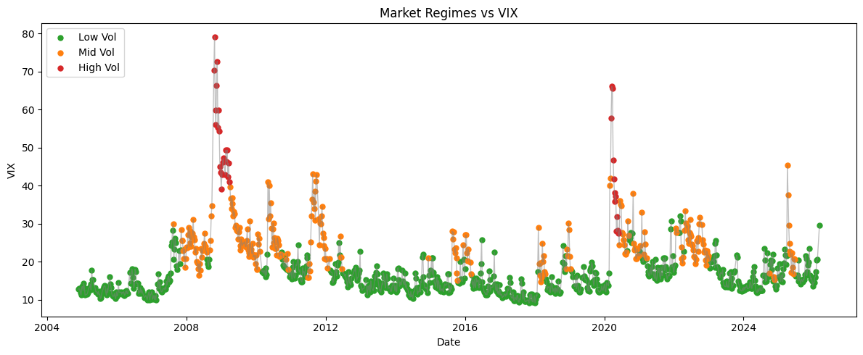
Figure 3. Market regime classification overlaid on the VIX time series. Data points are colored by regime, with green representing low-volatility periods, orange representing transitional conditions, and red representing high-volatility environments.

To further evaluate the economic characteristics of each regime, Table 1 demonstrates the difference in characteristics between the three produced regimes. The average VIX increases monotonically across the regimes (low < medium < high), consistent with their volatility labels.

Table 1. Summary statistics by regime for training dataset
Regime | Avg SPY Return | Avg VIX | Avg Volatility
High_Vol | -0.00308 | 52.49 | 0.0556
Mid_Vol | 0.000014 | 25.7 | 0.0284
Low_Vol | 0.003313 | 14.86 | 0.0186

The regimes exhibit clear economic separation. Low-volatility periods are associated with positive returns and stable conditions, while high-volatility periods correspond to elevated risk and negative returns. The intermediate regime captures transitional market environments with moderate risk and muted returns.

Supervised:

To extend the unsupervised regime labels into a forward-looking framework, we implemented two supervised approaches: a direct multiclass model and a two-layer conditional model. Both approaches were trained using only information available at time t to predict the next week’s regime, preserving chronological order and reducing the risk of data leakage. The supervised dataset combined weekly market and macroeconomic features, including S&P 500 and Nasdaq returns, momentum, VIX changes, realized volatility measures, yield spread, and multiple lagged terms. Additional transition-sensitive features such as volatility ratio, volatility spread, and rolling returns were also included in the direct model.

The direct multiclass approach, referred to as the Arun Direct Model, predicts the next regime label in a single step. We evaluated both logistic regression and random forest classifiers for this task. Logistic regression used standardized inputs with class balancing, while the random forest was trained on the full feature set with balanced class weights. Model selection was based on validation accuracy, and the random forest was selected as the final direct model due to stronger validation performance.

Because regime transitions are relatively rare, we also implemented a two-layer framework. In the first layer, the model predicts whether the regime will change or not in the following week. Logistic regression and random forest classifiers were evaluated, with logistic regression selected due to its ability to support threshold tuning. Rather than using the default 0.5 cutoff, the decision threshold was optimized on the validation set using F1 score for the rare “change” class, improving sensitivity to transition events. F1 was used as the tuning parameter because it allowed the model to catch true regime changes while avoiding too many false positives. Using accuracy would result in many false negatives (no change), and using recall would result in too many false positives (change), and using precision can potentially cause the model to miss real positives (change).

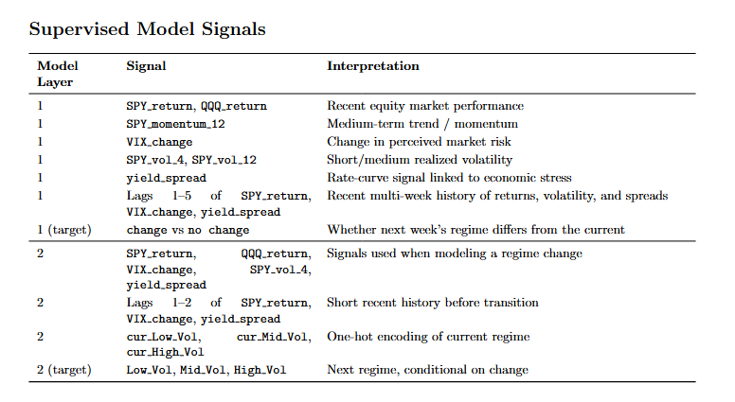
Figure 4. Supervised Model Signals

In the second layer, the sample was restricted to observations where an actual regime change occurred. A conditional logistic regression model was then trained to predict the next regime given that a transition had taken place. This model used a narrower feature set consisting of contemporaneous and lagged market indicators together with one-hot encoded indicators for the current regime. Performance was compared against a conditional baseline derived from the training transition matrix, which predicts the most common next regime given the current one.

The full two-layer pipeline combines both stages mechanically. If Layer 1 predicts no change, the final prediction remains the current regime. If Layer 1 predicts change, the observation is passed to Layer 2 to determine the destination regime. This structure separates rare-event detection from destination classification and is particularly useful in a setting where regime changes are infrequent and persistence is a strong baseline.

While the two-layer framework is designed to improve regime classification, its primary purpose in this project is to support downstream portfolio allocation. The model’s predictions are not evaluated in isolation, but instead used as signals to dynamically adjust asset weights across different market regimes. By separating regime change detection from regime classification, the two-layer structure is particularly useful for identifying transitions into higher-risk environments, which directly informs defensive portfolio positioning.

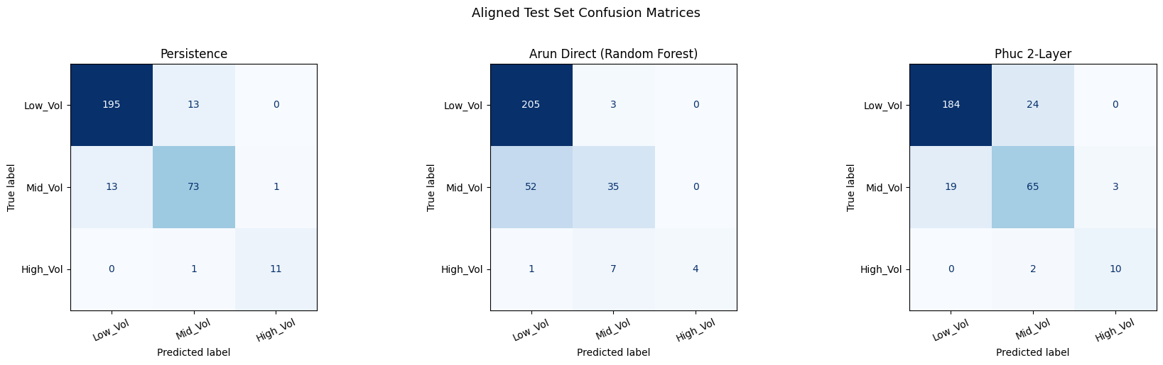

Figure 5. Confusion matrices comparing regime classification performance across models on the test set, including a persistence baseline, a random forest model, and the final two-layer framework.

Table 2. Model performance comparison.
Model | Validation Accuracy | Test Accuracy | Test Precision (weighted) | Test Recall (weighted) | Test F1 (macro)
Persistence Baseline | 0.9728 | 0.9088 | 0.9088 | 0.9088 | 0.8977
Direct Model | 0.9728 | 0.7948 | 0.7978 | 0.7948 | 0.6367
2-Layer Baseline | 0.9116 | 0.8404 | 0.8422 | 0.8404 | 0.8272
2-Layer Model | 0.9116 | 0.8436 | 0.8466 | 0.8436 | 0.8086

We evaluated all supervised models against a persistence baseline, which assumes the next regime will be the same as the current regime. The persistence model achieved the highest test accuracy (0.9088), reflecting strong temporal dependence in regime labels. The direct multiclass model achieved 0.7948 test accuracy, while the two-layer baseline and full two-layer model achieved 0.8404 and 0.8436, respectively.

Although the two-layer framework does not exceed persistence in raw classification accuracy, it provides a more structured and forward-looking approach by explicitly modeling regime transitions. The direct multiclass model underperforms across most metrics, indicating the difficulty of predicting multi-class regime outcomes in a single step under class imbalance.

These results highlight an important trade-off: while persistence maximizes accuracy, it lacks predictive value for future changes. In contrast, the two-layer framework improves the identification of regime transitions, making it more useful for downstream portfolio allocation, where anticipating changes in market conditions is more valuable than simply maintaining the current state.

Regime Allocation Strategy:

To evaluate our framework, we conducted a backtest comparing regime-based investment strategies with traditional benchmarks over the out-of-sample test period (2021–2026), including the COVID-19 recovery and subsequent market cycles.

In low-volatility regimes, the strategy increases exposure to growth-oriented assets such as equities, while in high-volatility regimes it shifts toward defensive assets such as Treasury bonds and gold. This allows the portfolio to adapt to changing risk conditions rather than maintaining static exposure.

We compared regime-based strategies to buy-and-hold SPY and a static 80/20 portfolio (SPY/TLT). In addition to the final two-layer model, we evaluated multiple regime signals, including unsupervised clustering, a persistence baseline, and a direct supervised classification model. Portfolio weights were determined based on predicted regimes, with signals shifted forward by one week to prevent look-ahead bias.

For each model, we tested four allocation strategies: a baseline allocation (“Current”), an aggressive equity tilt, a sector tilt, and a defensive rotation. The asset universe included SPY, QQQ, TLT, GLD, and sector ETFs such as XLE, XLK, XLU, XLP, XLV, and XLF.

Table 3. Portfolio performance comparison.
Strategy | Return | Volatility | Sharpe (Sharpe, 1994) | Max DD
2 Layer Base – Defensive Rotation | 0.1411 | 0.1373 | 1.0275 | -0.1666
2 Layer Base – Sector Tilt | 0.1372 | 0.1388 | 0.9882 | -0.1679
2 Layer – Defensive Rotation | 0.1188 | 0.1336 | 0.8887 | -0.1666
2 Layer – Sector Tilt | 0.1159 | 0.1357 | 0.854 | -0.1679
Unsupervised – Defensive Rotation | 0.1021 | 0.133 | 0.7675 | -0.1913
Persistence – Defensive Rotation | 0.1021 | 0.133 | 0.7675 | -0.1913

In this framework, the two-layer model plays a central role by generating forward-looking regime signals that directly drive portfolio allocation decisions. Specifically, predicted regimes determine the allocation map applied in each period, allowing the model to shift between growth-oriented and defensive asset mixes. This integration of regime prediction and allocation enables the portfolio to respond proactively to changing market conditions rather than reacting to realized volatility.

In addition to fixed regime-based allocations, we incorporate a dynamic allocation component that adjusts asset weights based on relative performance within each regime. This extension allows the portfolio to adapt not only to changing market conditions, but also to variation in asset performance within regimes. While our primary results focus on the regime-based allocation strategies, this dynamic framework provides additional flexibility for future extensions.

Findings and Conclusions:

Our dataset contains several limitations. Survivorship bias may be present, as the analysis relies on assets available through Yahoo Finance, excluding securities that were delisted or restructured. Selection bias is also a concern, as the dataset focuses on major indices and liquid ETFs, omitting other asset classes such as private equity, real estate, and smaller-cap securities. While the modeling framework minimizes data leakage through chronological splits, some risk of unforeseen look-ahead bias remains inherent in time-series analysis.

The results indicate that regime-based strategies can improve risk-adjusted performance relative to traditional allocation approaches. While the model does not consistently outperform a buy-and-hold SPY strategy in total return, it demonstrates competitive performance and, in several configurations, outperforms the static 80/20 portfolio.

Across models, allocation strategy plays a critical role in determining performance outcomes. Defensive Rotation and Sector Tilt consistently outperform baseline and aggressive allocations, indicating that adapting exposure based on volatility regimes provides meaningful benefits.

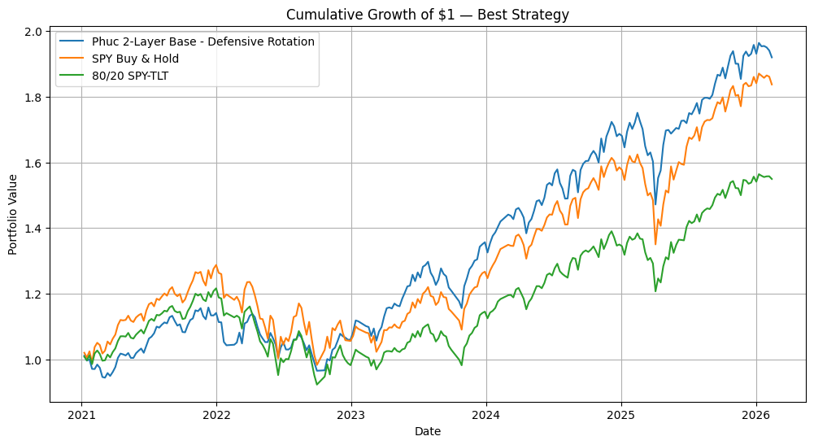
Figure 6. Illustrative defensive rotation framework. In low-volatility regimes, the portfolio emphasizes growth assets (SPY, QQQ, XLK), while in high-volatility regimes it shifts toward defensive assets such as Treasury bonds (TLT), gold (GLD), and defensive sectors (XLU, XLP). This figure represents a conceptual allocation approach; actual portfolio weights used in backtesting are dynamically determined and may differ.

Among all strategies, the strongest performance is achieved by the two-layer base model combined with Defensive Rotation, which delivers the highest risk-adjusted return and reduced drawdowns. While the two-layer framework performs strongly overall, results show that improvements in predictive modeling do not always translate directly into better portfolio performance. Simpler approaches, such as persistence and unsupervised signals, produce comparable outcomes in some cases, highlighting the importance of allocation design over predictive accuracy alone.

Importantly, the regime-based framework provides stronger downside protection during periods of market stress. During volatile market conditions, the model demonstrates reduced drawdowns relative to benchmark strategies, reflecting its ability to adapt to changing risk environments.

Overall, the findings suggest that regime-based allocation strategies offer a practical advantage in managing risk, particularly for investors focused on capital preservation and stability. Rather than maximizing absolute returns, the framework delivers more consistent performance across varying market environments.

Incorporating Feedback

Throughout the project, we incorporated mentor feedback to refine both our modeling approach and presentation of results.

Broader Impacts:

The proposed framework has practical applications for financial advisors and institutional investors by improving portfolio stability and reducing exposure during periods of elevated volatility. While it may not outperform in strong bull markets, it offers improved downside protection, which is particularly valuable for risk-averse investors and those approaching retirement.

The framework provides an alternative to traditional buy-and-hold strategies, which maximize long-term returns but require investors to remain fully exposed during periods of market stress. In contrast, the regime-based approach prioritizes risk management by dynamically adjusting exposure in response to changing market conditions.

From an ethical perspective, the models and findings presented are intended for educational purposes and do not constitute professional financial advice. Providing investment advice is a regulated activity requiring proper licensing and adherence to fiduciary standards under the Investment Advisers Act. As such, the authors are not qualified to provide investment recommendations.

Disclaimer:
The contents of this report and the models developed are intended for educational purposes only and should not be construed as professional financial, investment, or legal advice. The authors are not licensed financial advisors, and all models are provided “as-is” without any guarantee of accuracy or completeness. Readers should conduct their own due diligence before making financial decisions.

Author Contributions:

Arun Palaniappan (Co-Owner): Led the development and refinement of the written report and project video. Developed the random forest and logistic regression models and contributed to GitHub repository development and visualizations.

Phuc Nguyen (Co-Owner): Contributed to data acquisition, data cleaning, and feature engineering. Played a key role in both unsupervised and supervised modeling, pioneering the 2 layer model, as well as the development of the allocation framework. Also contributed to data visualization and analysis.

Spencer Cheung (Co-Owner): Led overall project direction and coordination. Responsible for initial data acquisition, data cleaning, and feature engineering. Implemented the unsupervised learning framework and contributed to the portfolio allocation approach. Developed the initial draft of the report and contributed to GitHub repository management and visualizations.

References:
Trading Dude. (2025). Volatility and market regimes: How changing risk shapes market behavior (with Python examples). Medium. https://medium.com/@trading.dude/volatility-and-market-regimes-how-changing-risk-shapes-market-behavior-with-python-examples-190de97917d8

Aslam, B. (2025). Identifying optimistic stocks with k-means clustering algorithm. International Review of Economics and Finance, 104, 104579. https://doi.org/10.1016/j.iref.2025.104579

BlackRock. (2024). Target allocation and portfolio rebalancing insights. BlackRock. https://www.blackrock.com/us/financial-professionals/investments/products/model-portfolios/portfolio-rebalancing-insights/target-allocation

Sharpe, W. F. (1994). The Sharpe ratio. Stanford University.
https://web.stanford.edu/~wfsharpe/art/sr/sr.htm

